**Training Data Set Creation**

The training data set used for this analysis is shown below (first 5 lines):

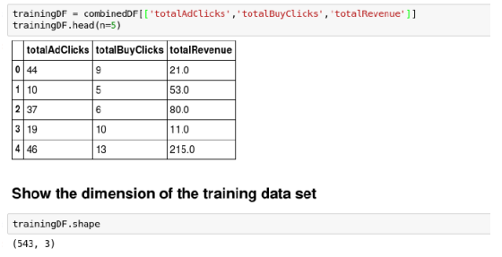

Dimensions of the final data set: **543 rows x 3 columns**

# of clusters created: **3**